Derek and Jane French began serving with Grupos Bíblicos Unídos (GBU) in 2007. GBU is a Christian student organisation affiliated to the International Fellowship of Evangelical Students. They are based in Bilbao in northern Spain.
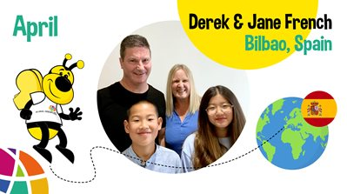
The work of GBU principally involves evangelism among students and the discipling of Christian students. GBU’s vision is to reach all non-Christian students with the gospel and to develop student leadership which, in the future, should contribute to the growth of evangelical churches in Spain. Derek and Jane are excited to be actively involved in a new project with the publishing branch of GBU (Andamio). The project aims to provide resources for Sunday school teachers, youth leaders and devotional materials for children and teenagers.
They are also involved in local church ministry in Bilbao, serving in the Bilbao International Church (BIC) and working alongside the local Spanish church.
Derek and Jane have two children, Gabriela and Luka, who go to local schools in Bilbao.
- Pray for Andamio Kids, the Christian Publishing Company as they select, translate, print and distribute books and resources for kids, Sunday School teachers and parents. The latest book they have published is for young kids and it is called “Jax’s Tail Twitches: When you are Angry”. This is a book that teaches kids how God can help them when they are feeling angry. They learn about the power of saying sorry, seeking forgiveness, remembering God’s words and praying together.
- Pray for the Bilbao International Church Sunday School. Currently they are learning about who Jesus is, through the Gospel of Luke. Pray that those who already know Christ will grow in their relationship with him and for those who maybe don’t yet know Christ, that they would come to faith in him.
- Pray for Gabriela and Luka. Gabriela sings in the worship group and helps out with Sunday School and Luka does the PowerPoint and the sound system in church. Pray that they would grow in their personal walk with God.
- Pray for the ministry with International Students in Bilbao International Church. Give thanks for those that meet up for 1-2-1 Bible studies and get involved in the church. Pray that God would use each one of them to be a witness for him as they return to their home countries after spending time in Bilbao.

