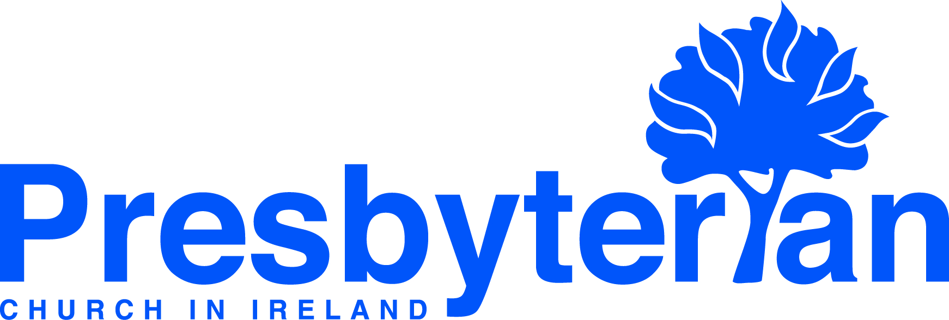
Let’s Pray | Sun 13 June - Sat 19 June 2021
Tuesday 15 June
- International Meeting Point | Pray for the staff and volunteers at International Meeting Point in South & North Belfast. Pray in particular for the Op Shop and for various meetings and Bible Studies as they restart in-person.
- St Columba’s, Lisburn | Pray for outreach into the community. Pray for "The Kid's Club" which began outdoors on 3 June and will run for six weeks. Give thanks for the great turnout so far. For many of those children this is their only "Sunday School". Pray for deeper links with their families.
Thursday 17 June
- Philip Whelton (Irish mission worker, Arklow) | Pray for preparations to resume some activities in the autumn. This includes keeping parents updated regarding children & youth clubs, and maintaining a visible presence in town to remain in contact with people & assure them of the church’s care and concern for their well-being.
- Strand (East Belfast) | Pray for good fellowship amongst the congregation meeting together on Sundays.
Pray for the children and young people who go to Sunday Pals, that many will commit their lives to Christ.
Saturday 19 June
- General Council | As congregations in Northern Ireland plan ahead for summer activities, pray for guidance for
kirk sessions and youth and children’s leaders. Please pray that restrictions in ROI will soon also allow such
activities to take place.
- Council for Training in Ministry | Three lecturer posts are vacant in Union College due to recent or pending retirements, and through colleagues moving on to new roles. Pray for the interview and selection process, that the Lord will guide clearly and that people will be appointed who he will be pleased to use in teaching students and training ministers.
Friday 18 June
- Social Witness | Pray for all the home managers within CSW as they continue to work through the most challenging period in the life of the Social Care Sector – that they may guide their teams with renewed energy
into this important transitional time of returning to more normal routines. Give thanks that we are blessed with managers, who have shown great dedication and compassion over the past 15 months.
- Council for Public Affairs | Following a recent meeting of the Council for Public Affairs pray for Rev Daniel Kane
in his role as convener and as the Church seeks to have its voice heard clearly in the public square.
Wednesday 16 June
- Naomi Keefe (global mission worker, Brazil) | Pray for the evangelistic activities Naomi is involved in around St John the Baptist day. They plan to distribute soap packages to families which include simple devotional material explaining how Jesus alone can cleanse our sins. Pray that many will turn to him in repentance and faith.
- Brazil | Pray for the people of Brazil who are suffering greatly from Covid-19. Pray for the witness of the Presbyterian Church of Brazil, that leaders and members will bring God’s comfort and strength to many.
Monday 14 June
- Middle East | Pray for students and staff at JETS as they engage in the theological teaching-learning process under some restrictions in relation to Covid-19. Thank God that in spite of the disruption caused by the pandemic, JETS continues its strategic role in the Middle East ‘training Arab leaders for the Arab world’.
- Myanmar | Pray for a just and peaceful resolution to the ongoing civil unrest following the military coup earlier this year. Pray for the leaders and members of the Presbyterian Church of Myanmar at this difficult time.
Sunday 13 June
- Moderator | As the ‘marching season’ approaches, pray for calm in Northern Ireland, especially in the light of recent street violence. Pray for the excellent work being done by PCI congregations in inner city areas.
- Being a prayerful people | Ask God to help us to be a prayerful people, aware of his presence with us, always looking to him expectant that he will lead, guide and direct our steps.

