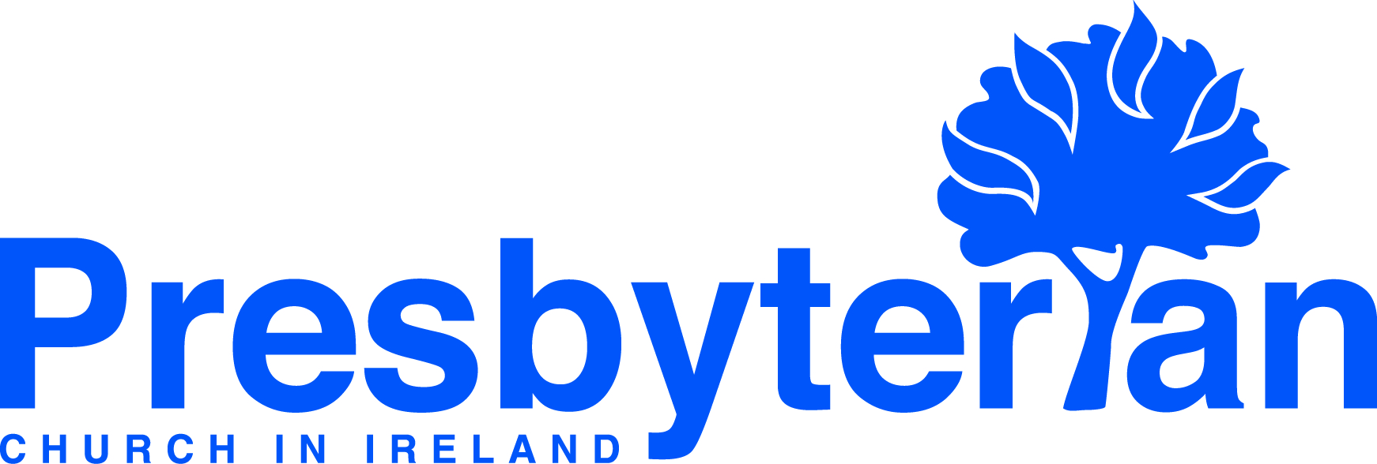
Let’s Pray | Sun 16 May - Sat 22 May 2021
Monday 17 May
- Global Mission - Covid-19 | Pray for those living in countries where healthcare and state support is limited. Pray for India where case numbers are extremely high and for neighbouring countries including Nepal where case numbers are rising fast. Pray for PCI’s partners in India and Nepal at this difficult time.
- Global relief and development | Pray for Christian Aid, Tearfund and PCI partners around the world involved in humanitarian relief and development work, reaching out to those in greatest need in the name of Jesus.
Thursday 20 May
- Lisbellaw, Lisnaskea, Maguiresbridge & Newtownbutler (Co Fermanagh) | Pray for the work and witness of these home mission congregations. Pray for wisdom and guidance for Rev Rodney Beacom and the kirk sessions.
- Maynooth | Pray for a return to face-to-face services and as they share their worship space with a new Irish school. Pray for the new building project - give thanks that the site contracts are finally ready for signing.
Saturday 22 May
- General Council | Pray for the meeting of the Irish Inter Church Committee (IICC) taking place during the
incoming week. This is the forum where the IICC’s denominations meet with representatives of the Bishops’ Conference to discuss issues of mutual concern.
- Linkage Commission | The Commission is due to meet on 25 and 26 May, with up to eight vacant congregations seeking permission to call a minister. Give thanks that the easing of Covid-19 restrictions now make it easier for congregations to hear and call a minister, and pray that the Lord will give wisdom to the Commission as they consider requests, and seek the upbuilding of the Lord’s Church.
Friday 21 May
- Social Witness | Pray for the work and witness of the Disability Services Committee as they oversee the work of Willow Brook, Aaron House, Lawnfield and Peacehaven. Pray for the residents and tenants as they adjust to new freedoms within the new guidelines.
- Victims and Survivors | Pray for those who have been impacted by the conflict in Northern Ireland and for
whom public discussions about dealing with the past trigger painful and distressing memories. Pray that they would know the reality of the peace and comfort that comes from God.
Wednesday 19 May
- James & Heather Cochrane (global mission workers in Portugal) | Pray that the new Bible Course which Comunidade Pedras Vivas is launching will help members to share the Bible with friends and neighbours.
- Volker & JinHyeog Glissmann (global mission workers in southern Africa) | Pray for Volker as he works with colleagues in the Theological Education by Extension College in Johannesburg, revising courses for their distance learning programme. They are working through the Christian Ethics workbooks at present.
Tuesday 18 May
- University & College Chaplains | Pray for Rev Dave Gray at Queen’s University Belfast & Derryvolgie Halls & Revs Cheryl Meban, John Coulter & Graeme Orr at the various campuses of Ulster University as they continue to support students and staff during Covid-19 restrictions. Pray for students preparing for and sitting exams.
- Prison Chaplains | As restrictions ease & chaplains are allowed more contact with prisoners, pray for wisdom and God’s guidance for them as they seek to bring the hope of the gospel and transformation to many.

Sunday 16 May
- Moderator | Pray for politicians in all parties as they debate matters which affect us all. Especially, pray regarding the major liberalisation to abortion legislation in Northern Ireland.
- Strength and peace in worship | ‘The Lord give strength to his people; the Lord blesses his people with
peace.’ Psalm 29:11. Today as we worship in person, online or on our own, ask God that he would strengthen
us as his people and bless our hearts with his peace.

