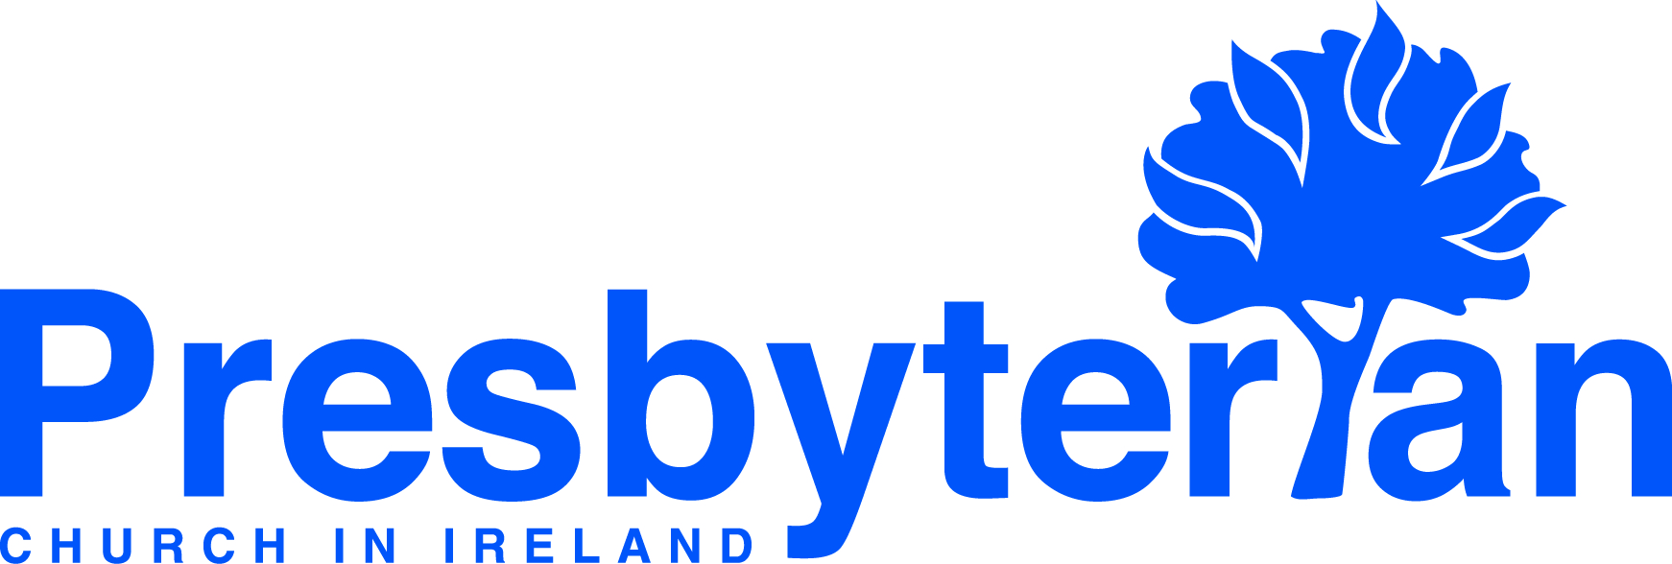
Let’s Pray | Sun 27 Sept - Sat 3 Oct 2020
Wednesday 30 September
- Portugal | Give thanks for the growth of CPV in Porto, where the Cochranes and Humphries are serving. Pray for the church as they seek to serve God while complying with Covid-19 restrictions.
- Portugal | Pray for the new church members, that they would know God’s hand on their lives and that he would use them wherever he has placed them.
Monday 28 September
- Global Mission Partners | Pray for our global mission partners in countries like South Sudan, Myanmar and Indonesia, many of whom are struggling because of the impact of Covid-19 on food security, health systems and infrastructure.
- Leaders in Training | Pray for Wamaka Nyondo from the Church of Central Africa Presbyterian, Malawi. Wamaka has just returned home after completing a Masters degree in Edinburgh, supported by PCI. He plans to work in the Synod’s health department.

Tuesday 29 September
- University and college chaplains | Students are returning to universities and colleges around Ireland. Pray for the PCI chaplains as they seek to support them on their return to education after a long break.
- Derryvolgie Hall | Pray for the students who are settling in at Derryvolgie, some for the first time. Pray that they will find an encouraging environment that will build them up in their faith as they navigate university life.

Sunday 27 September
- Moderator | Pray for the Moderator as he continues to provide a weekly online service for the Presbyterian church family and also as he commences visits to churches: Ballyhenry on Sunday 27 September and the re-opening of 1st Anaghlone on 3 October.
- Arrangements for worship | Give thanks for all those involved in making worship possible today in your church building – those who open up, clean, steward, lead. Ask that God would bless their work.
Friday 2 October
- Safeguarding | Pray for confidence and competence in safeguarding within children’s and young people’s ministries. Pray for the ability of leaders to continue to ensure the safeguarding of our young ones whilst continuing to witness to them.
- New Opportunities | Pray that in the midst of complexity and concern, political and civic leaders might have space to consider new opportunities for how we live and work together in a society that encourages human flourishing.

Thursday 1 October
- International Meeting Point | Pray for IMP’s weekly Bible study, which has recently restarted. Pray that the attendees would be receptive to God’s Word and come to know him better.
- International Meeting Point North Belfast | Pray for the IMP Op Shop, its volunteers and its customers. Pray for continued opportunities to reach out to those who may have no other contact with the church.

Saturday 3 October
- General Council | Pray for the General Council as its Standing Committee tries to take forward work on behalf of the Council and draws up plans for the future of PCI in challenging and ever-changing circumstances.
- Union Theological College | The current semester began on 21 September. Pray for students and staff that there may be good learning and teaching in classroom and online amid all the Covid-19 precautions.

