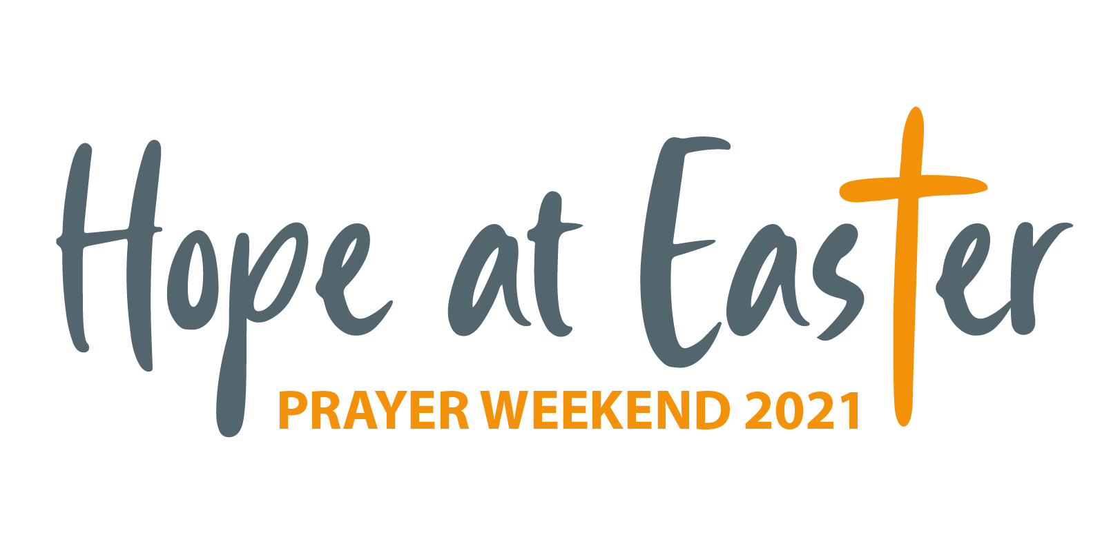

|  |  |
| --- | --- |
| **Let’s Pray** | **Sun 28 March** - **Sat 3 April** 2021 |

**Saturday 3 April**

* **Hope at Easter |** *The Moderator will offer a pre-recorded service of worship this Easter which may be used in congregations across the Church. Pray that this would be a blessing to many. Thank God for the provision of technology to enable us to meet online.*
* **Hope at Easter |** *Pray for the Taoiseach, Micheál Martin, and his Coalition Government in the Republic. Pray   
  for the NI First Minister, Arlene Foster and the Deputy First Minister Michelle O’Neill, as they seek to lead the   
  Northern Ireland Executive. Pray for the NI Secretary of State, Brandon Lewis.*

**Friday 2 April**

* **Hope at Easter |** *On this Good Friday, why not take some time to pause in the course of the day to consider the words of the Centurion who while guarding the cross and witnessing the events on the day of Jesus’ death said. “Surely he was the Son of God!” He died for me.*
* **Hope at Easter |** *The Church Leaders will be leading an act of worship on Easter Sunday, which will be   
  broadcast on television by BBC Northern Ireland. Pray that the message of hope emerging from the cross and resurrection would be heard and understood by all who watch.*

**Thursday 1 April**

* **Hospital chaplains |** *Pray for protection, strength and stamina for PCI hospital chaplains. Pray for all those ill in hospital, for a full and quick recovery and that patients who don’t have Covid-19 will be protected from it. Pray too for staff working in very challenging conditions and for families whose visits are restricted.*
* **Gortin |** *Pray for the congregation as it approaches a second year of being vacant. Pray for the members as they look forward to meeting again to worship together in person and for wisdom in calling a new minister.*

**Wednesday 31 March**

* **Derek & Jane French (global mission workers in Spain) |** *Pray for Derek for a quick and successful recovery from a recent* operation. *Pray too for Bilbao International Church and the leadership team as they take on more responsibility and for those coming to the church who are seeking, that they will come to faith in Christ.*
* **Malawi |** *Pray for the Student Christian Organisation of Malawi and Scripture Union Malawi as they spread the gospel to children and teenagers in Malawi and seek to disciple young Christians in their Christian faith.*

**Tuesday 30 March**

* **Paula Burrows (deaconess in Ballygrainey) |** *Pray for Paula and the work she is involved in which includes the Lighthouse Club, Tweenies group, women's discipleship (through PW and other small group settings) and developing mission opportunities in the community through Holiday Bible Clubs, Bangor Cares, etc.*
* **Galway |** *Pray that online services and gatherings would be used for God's glory. Pray for the leaders, for youth & student work, for those doing online membership classes and for children’s ministry. Pray for revival in the West.*
* *Pray that those who have been reading the New Testament for the first time would come to know Jesus.*

**Monday 29 March**

* **Naomi Leremore (global mission worker in Kenya) |** *Ask for God’s blessing on the Theological Education by Extension’s curriculum team which Naomi is part of, as they design a mentoring book for girls. Pray over their first meeting which will take place in April and for the preparation work needing to be done beforehand.*
* **Myanmar |** *Pray for Myanmar following the recent military coup and protests against it. Pray for peace and for the restoration of democracy. Pray too for the leaders and members of the Presbyterian Church of Myanmar.*

**Sunday 28 March**

* **Moderator |** *With Easter approaching, the Moderator will reflect on the theme of Hope during a number of services and at other events. Give thanks that our times are in God’s hands, and that because of this we can be a people of hope in trying times.*
* **Worshipping with Easter in sight |** *Today as we worship with Easter in sight, ask God that on this Palm Sunday we might know the reassurance that Jesus is King and praise him as the one who still comes to us in   
  the name of the Lord.*