

Prayer Points ~ April 2019

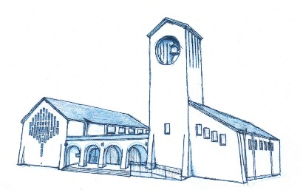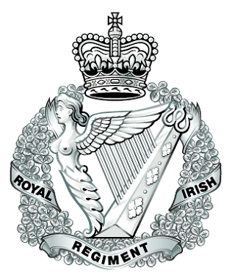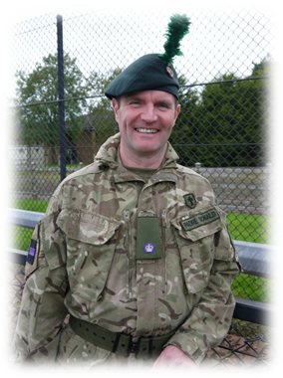

Minister—First Garvagh Presbyterian Church

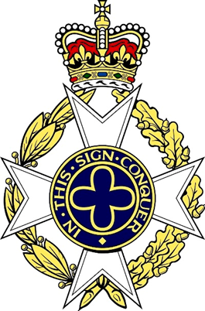



* Please pray for travelling mercies throughout the deployment.
* Pray that I will pass through the final stages required to   
  mobilise, especially the couple of days I will spend at Chilwell on   
  Mission Preparation including the medical.
* Pray for God’s protection and care to be upon Elaine & Sarah at home and our extended family. May the time pass quickly.
* Pray that God will empower, protect and equip me and keep me in good health while in Afghanistan.
* Pray for the safety and protection of all those who are   
  deployed overseas in hostile situations and for their families back home.
* Pray for opportunities to share the good news of the gospel, especially with those of the 1st & 2nd Battalion The Royal Irish Regiment.
* Pray for good numbers to attend worship services and also for opportunities to deliver either a Life Explored or Scripture Union ‘Nua’ course.
* Pray for God’s blessing and encouragement to be upon  
  Rev. Dr. Isaac Thompson who is covering for me.
* Pray for the congregation of First Garvagh, especially those who are ill.

