The Green Jacket and the greatest prize of all
Date posted: 06/04/17
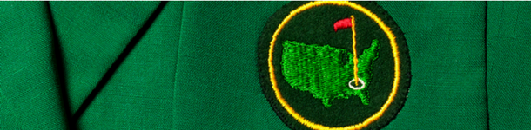

On Sunday night, the winner of the Masters will be presented with the famous Green Jacket. It may not be a gleaming trophy, but it has to be one of the most coveted prizes in sport, let alone golf. In fact, it is probably its unusual nature that adds much to its allure.
With its perfect fairways and manicured greens, the Augusta National course has a magic and intrigue of its own. The colours look amazing, even to a TV audience. There is not a weed in sight and the ground staff pride themselves on this. The Green Jacket is therefore the crowning glory for conquering a golf course that is as near to aesthetic perfection as man can achieve.
There is some great history to it as well. The Green Jacket was first introduced in 1937 as a means for club members to be visible when the public needed help. It was not until 1949 that Sam Snead became the first winner to be honoured with one.
That jacket presented on Sunday will be borrowed from an Augusta member of similar build to the winner before he then gets his own tailored one later. The champion can keep his jacket for a year before it is returned to the club. After that, he can only wear it when he is at Augusta. The only exception was when 1961 champion Gary Player forgot to return his jacket the following year and was allowed to keep it at home in South Africa – although he has agreed never to wear it in public.
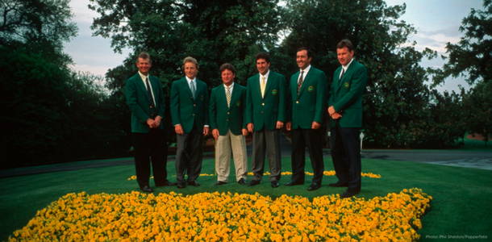

As the players vie for the honour of wearing the Green Jacket on Sunday night, is it fair to say that this is sport’s greatest prize? It is surely the most iconic piece of sporting clothing. What other prizes would you put alongside it? The golden FIFA World Cup? An Olympic gold medal? For sheer size, it is hard to beat ice hockey’s Stanley Cup or the Indy 500 motor racing Borg Warner Trophy. But the Green Jacket is such a unique prize. There is nothing quite like it. Certainly, for a golfer, there is no more prestigious trophy. It’s THE prize everyone wants to win.
It is striking, though, that even if you win the Green Jacket, you can’t wear it whenever and wherever you want. Tradition dictates it must stay at the Augusta National. It’s a massive deal, but it’s not a prize you can fully keep hold of, no matter how many times you win the tournament. Similarly, you will always lose your title at some point. There will always be a new champion to succeed you.
The apostle Paul writes about a prize in chapter three of his letter to the Philippians. In verses 13 and 14 he says this:
But one thing I do: forgetting what is behind and straining towards what is ahead, I press on towards the goal to win the prize for which God has called me heavenwards in Christ Jesus [NIV].
Paul probably wasn’t a sportsman, but before this in verses four to six, he has been talking about his own prizes – the achievements that mark him out. They may not mean much to us nowadays, but Paul relates how he was the ultimate Jew. He had the right upbringing, the right background, the right education and the right status. If Judaism was a sport, he would have won a green jacket, a gold medal and anything else that was on offer. He could walk into any situation and command respect, much like a Masters champion could walk into any golf club around the world and get playing.

